

FOR IMMEDIATE RELEASE
December 5, 2008
Contact: Meg Meo, Elizabeth Christian & Associates Public Relations
512-494-2867 or mmeo@echristianpr.com

Asian American Bar Association & Foundation donate $14,000 to Hurricane Ike Relief Fund

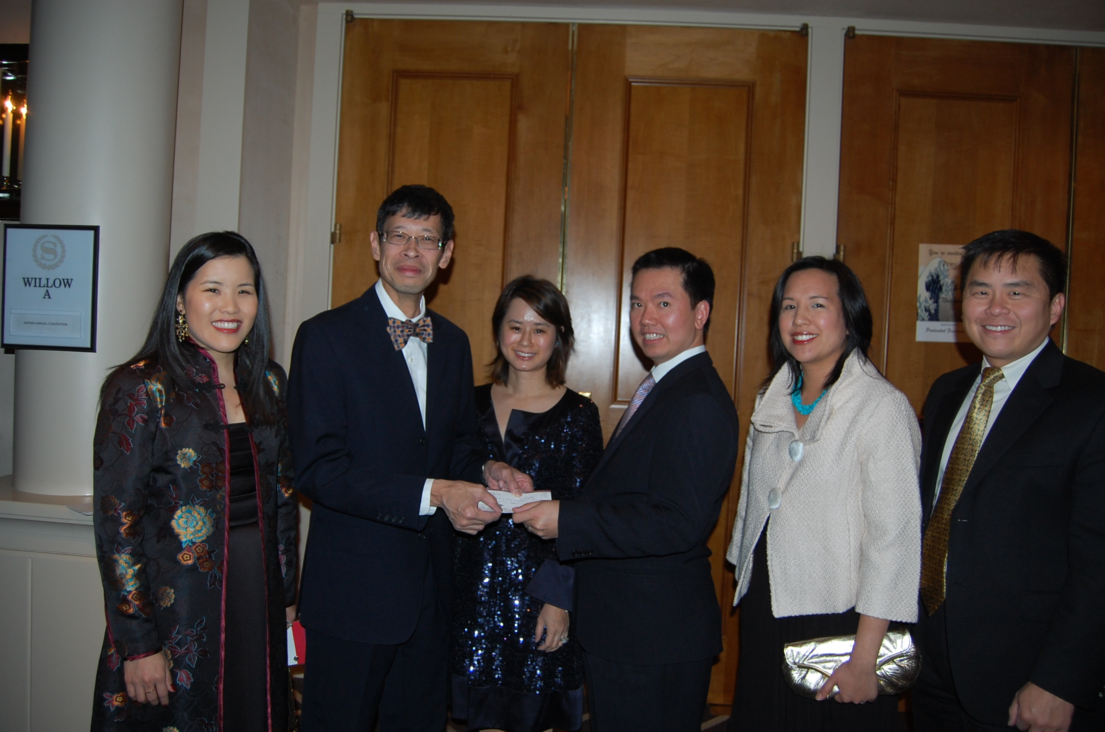
Texas Access to Justice Commissioner Daniel Hu accepts $14,000 for the Texas Access to Justice Foundation Hurricane Ike Relief Fund donated by the Asian American Bar Association (AABA) and the Asian American Bar Foundation (AABF) raised at their annual gala in Houston.

Left to right. AABF trustee Emily Kuo, Daniel Hu, AABA President Catherine Than, AABF Chairman Quan Vu, AABA Vice President Joyce Kao Soliman, AABA Committee Chair Stephen Wu.
-30-
The Texas Access to Justice Foundation (www.teajf.org), created by the Supreme Court of Texas in 1984, is the primary state-based funding source for the provision of civil legal aid in Texas. The organization is committed to the vision that all Texans will have equal access to justice, regardless of their income. The Foundation administers a variety of funding sources, which are earmarked to assist nonprofit organizations in providing legal aid to approximately 100,000 Texans each year.

